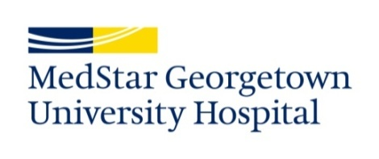

Requirements for Employment at MedStar Georgetown University Hospital

Employment at MedStar Georgetown University Hospital is contingent upon satisfactory completion of a pre-employment drug screen, criminal background clearance, receipt of satisfactory credentials, satisfactory health clearance, and completion of Institutional Orientation.

MedStar Georgetown University Hospital strives to maintain the highest standards of patient care. Consistent with this objective, we require our employees, as a condition of employment or continuing employment, to obtain vaccinations, such as the influenza (flu) vaccine, or adopt other precautions as we deem necessary to protect our patients from unnecessary exposures. Of necessity, the specific requirements vary from time to time depending on the public health environment.

